**InsightStream: Navigate the News Landscape**

**Ideation Phase**

**Brainstorm & Idea Prioritization**

|  |  |
| --- | --- |
| Date | 10 march 2025 |
| Team ID | SWTID1741257592149925 |
| Project Name | InsightStream: Navigate the News Landscape |
| Maximum Marks | 4 Marks |

**Step-1: Brainstorm, Idea Listing and Grouping**

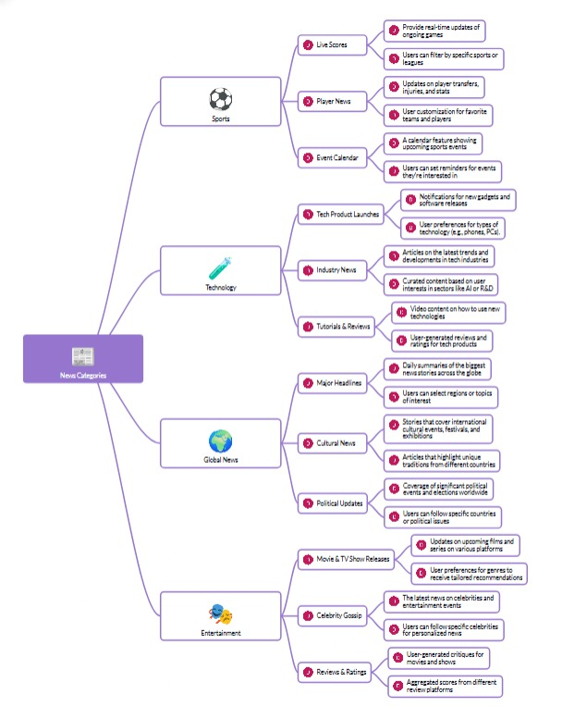

This mind map visually represents different news categories and their subcategories, showing how information can be personalized and tailored based on user preferences. It divides news into four major sections:

Sports

Live Scores (real-time updates on games)

Player News (transfers, injuries, and stats)

Event Calendar (upcoming matches and events)

Technology

Tech Product Launches (notifications on new gadgets and software)

Industry News (latest trends and developments)

Tutorials & Reviews (video content, user-generated reviews)

Global News

Major Headlines (daily summaries of significant events)

Cultural News (stories on festivals, traditions, and international cultures)

Political Updates (coverage of elections, policies, and world affairs)

Entertainment

Movie & TV Show Releases (updates on new films and shows)

Celebrity Gossip (news about famous personalities)

Reviews & Ratings (aggregated scores and user critiques)